1. **Exercise-2 – White box testing exercise**

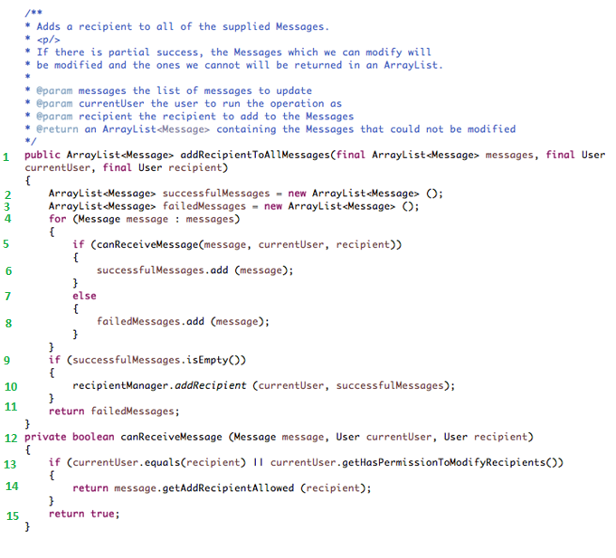

*Added statement number to given code snippet.

From the given code following statements can be derived,

Recipients can be added to messages if

* + currentUser is recipient or currentUser has permission to modify recipients
  + message should allow to add recipients

1. Following are the bugs in the given code,
2. Referring statement 13 - If currentUser is not a recipient and does not have permission to modify recipients, function ‘canReceiveMessage’ will return true and messages will still be added to successfulMessages.

Modified function – canReceiveMessage,

*private Boolean canReceiveMessage(Message message, User currentUser, User recipient)*

*{*

*if (currentUser.equals(recipient) || currentUser.getHasPermissionToModifyRecipient())*

*{*

*return message.getAddRecipientAllowed(recipient);*

*}*

*return false;*

*}*

1. Referring statement 9 & 10 – Adding recipient to successfulMessages when successfulMessages Arraylist is empty.

*If (successfulMessages.isEmpty())* statement can be modified to *if(****!****successfulMessages.isEmpty())*.

1. Reason for current test to pass:

Current test has input conditions,

* Current user is recipient

This condition makes goodMessage and badMessage process properly due to ‘if’ condition mentioned at statement 13 in above code snippet.

1. **Exercise 2 – Specification Review Exercise**

**Specification:**

* Only writeable users should be able to edit their profile.
* As a user I can only edit my own profile.
* As a CSR I can edit any user.
* Edit Profile and Change password should have the same behavior for a user editing his/her profile and a CSR editing a profile.

1. **Aspects unclear or risky:**
2. **Provided mockup diagrams does not provide information about CSR user’s view for editing any user. How CSR is going to select/search any user and edit profile?**
3. **Provided specification and mockup diagrams does not mention authorization levels for normal user and CSR.**
4. “Edit Profile and Change password should have the same behaviour for a user editing his/her profile and a CSR editing a profile.”

**This specification does not specifically mention about “same behaviour”. What is expected common behaviour on edit profile, change behaviour and CSR editing a profile?**

1. **List of queries:**

**Profile Page:**

1. What message should be displayed if user is not writeable and tries to edit profile?
2. If user is not writable will ‘Edit Profile’ option be visible?
3. Will user be allowed to change photo on profile page?

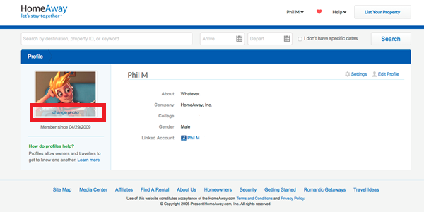

**Edit Profile:**

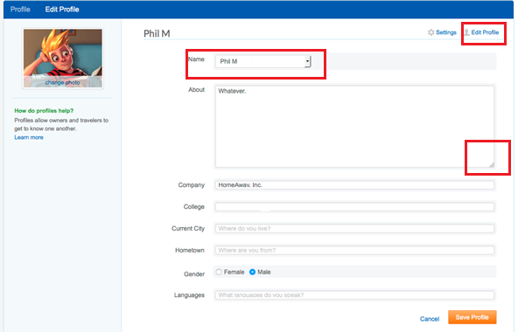

1. Why ‘Name’ field is a dropdown and not textbox?
2. Should ‘Edit Profile’ link should be visible when user is already on ‘Edit Profile’ page?
3. Are constraints regarding no. of characters and allowed characters on editable textboxes on ‘Edit Profile’ page defined?
4. ‘About’ text area looks resizable? Is it required to be resizable? How layout should change if user resizes text area? Instead of resizable control can we limit on its size? If user exceeds given text area will scrollbars be shown?
5. When user clicks on ‘Save Profile’ button what is expected to happen? (Will he be shown with ‘Profile Successfully updated’ message? Will ‘Save Profile’ action redirect user to some other landing page? If yes what would be the layout of that page?)
6. What are the mandatory fields on ‘Edit Profile’ page? If there are any mandatory fields are they going to be marked?
7. What are the validation conditions on ‘Edit Profile’ page?
8. What validation error messages should be shown if user misses any information and tries to ‘Save Profile’?
9. What should happen if normal user and CSR edit same profile at the same time?

**Settings:**

1. Should ‘Settings’ link should be visible when user is already on ‘Settings’ page?
2. What should happen when user deactivates Home Away profile?
3. What should happen when user removes linked account? How UI should change after removing the linked account?

**Generic (Edit Profile and Settings):**

1. Will user be able to navigate using breadcrumbs provided at the top of the page? If user navigates to profile page will system validate edited form?
2. What should happen if user navigates to any other page from ‘Edit Profile’ or ‘Settings’ page? (Should user get a pop-up message warning him about losing recently edited unsaved information?)

**Reset Password:**

1. It is unclear how user lands on the ‘Reset Password’ page.

(If user lands on ‘Reset Password’ page from Login Page then first ‘Reset Password’ page should ask user to enter his/her registered email to get the password reset link. If email is valid only then an email with password reset link should be sent. Once use click on password reset link in email then he/she should be allowed to reset the password.)

1. What should happen if two passwords do not match?
2. What should happen when user clicks ‘Save Changes’ button?
3. Should button be renamed as ‘Reset Password’?
4. **Important queries and reason for why those are important queries, expected answers and impact on development work:**

I would select following questions to ask. It might require more than 10 minutes to get answers to following questions, in that case Product Manager should agree to respond back in email with the answers. OR she can assign a point of contact who can answer queries in her absence.

1. Provided mockup diagrams does not provide information about CSR user’s view for editing any user. How CSR is going to select/search any user and edit profile? Are we designing in a page where CSR can search users and edit their profiles?

**Why this question? :** It is important to know how CSR is going to know about users in the system that he/she can edit. Where should the search user option be placed in UI? How search user page should look like? OR Can CSR login as any specific user?

**What answer is expected? :**  Answer could either be a search user page or login CSR as any user.

**Impact on development:** Development team has to work on new functionality – ‘Search user’. They could have taken a decision themselves to develop edit any user profile feature for CSR but answer to this question will give them clearer picture of what is actual expectation.

1. What are expected authorization levels for normal user and CSR?

**Why this question?** : Team should be aware of access permissions for normal user and CSR for edit profile and settings page.

**What answer is expected?** : PM should explain access permissions for various functionalities on edit profile and settings page. E.g. Only CSR should be able to ‘Deactivate account’. Name field on edit profile page will have dropdown control for CSR and text box for normal user.

**Impact on development:** Access permission implementation is very important part of any system. It requires careful design and implementation. Based on the answers provided development team can decide about the implementation and whether to take-up this requirement in current iteration.

1. What does it mean by same behaviour? (“Edit Profile and Change password should have the same behaviour for a user editing his/her profile and a CSR editing a profile.”)

**Why this question? :** From the specification it is not clear what ‘same behaviour’ is expected across ‘Edit Profile’ and ‘Resent Password’ pages.

**What answer is expected?** : PM should clarify expected behaviour. It could be related to same look and feel for ‘Edit Profile’ and ‘Reset Password’ across user roles. Same validations, error/warning messages.

**Impact on development:** Based on the clarification development team will get more insight on what is expected behaviour for this specification and accordingly they can change the implementation.